**برگرفته از مقاله:Incorporation of Blockchain Technology for Different Smart Grid Applications: Architecture, Prospects, and Challenges**

For over a century, electricity has been transmitted from generation to customer end using a one-directional conventional grid system. However, as human civilization progresses rapidly, more fossil fuel-powered power plants are used, resulting in higher greenhouse gas emission. Consequently, the electricity grid has become a very complicated system. Cascade failures are also more likely to occur in this new setting. Several major blackouts have occurred throughout the globe in the last decade. A smart grid is a futureoriented electrical network supporting renewable power sources, smart distribution, and dynamic load shedding. These characteristics also help prevent cascade failures. A great deal of data about the grid’s markets, service providers, and operations must be controlled. In other words, as seen in Figure 1, a smart grid is a highly decentralized and structured communication network to transport and analyze the data gathered. As has just been discussed, wireline and wireless connectivity technologies are used in tandem in a smart grid to facilitate power transfer and management. The purpose of a SCADA system is to keep tabs on the status of a power grid at both the transmission and distribution levels. Instead, data are sent across the network through a number of utility gateways.

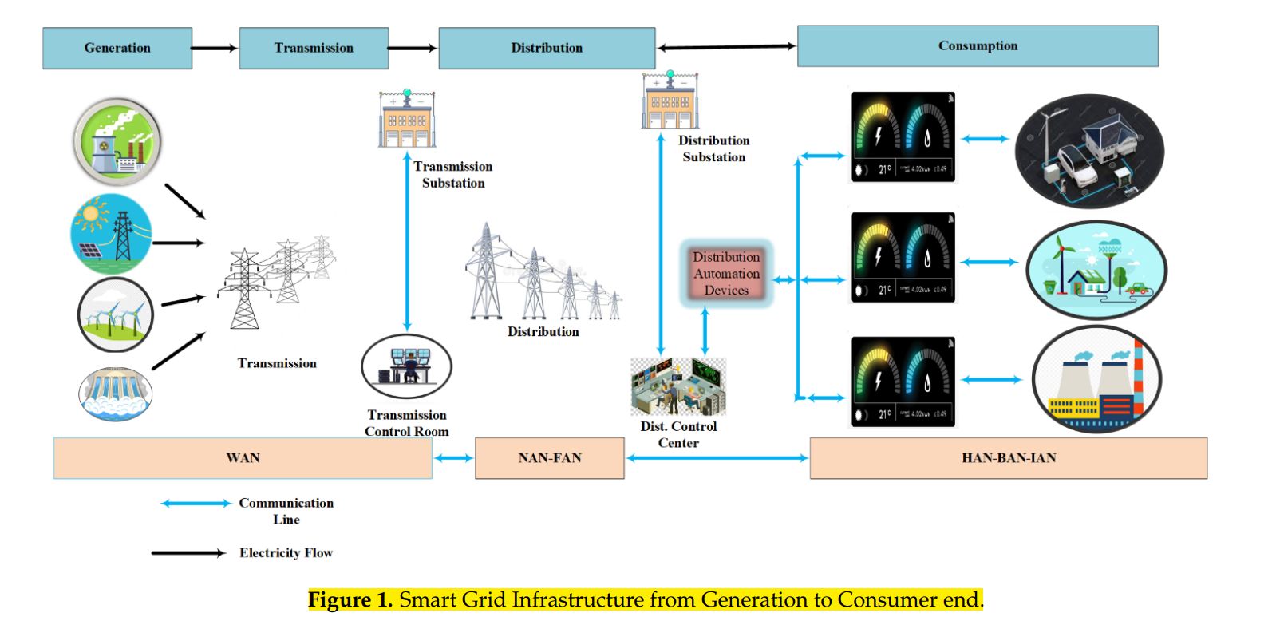

Given the rise in popularity of alternative energy sources, faster signal processors, smarter sensors, etc., the power grid is experiencing rapid evolution. The current need calls for a two-way exchange of data and energy between power producers and consumers [1]. As a result, the conventional power grid is transitioning into a smart grid (SG), a system that can dynamically monitor and manage electricity flow, giving customers stable power [2]. Smart grid integrates computer, communication, and sensing technologies into existing power grid networks to achieve these significant informatization-related advantages. Energy management systems (EMS), electric vehicles (EVs), microgrids (MGs), smart cities (SCs), home automation (HA), and advanced metering infrastructure (AMI) are some of the most prominent examples of SG applications [2].

SG improves power supply dependability and makes various complex and difficult applications a reality [3]. Multiple entities in the grid conduct transactions at any time in this intricate network. Verifying the legality of the business dealings between the parties to a specific SG application is a major issue. Blockchain technology offers a safe and promising answer to this issue. Satoshi Nakamoto’s invention of blockchain technology facilitates agreement on the legitimacy of a transaction and keeps everyone involved honest [4,5].

Figure 2 displays the annual number of articles covering blockchain research. In addition, the chart displays the comparable number of articles written on blockchain for SG. Scopus was used to compile the tally of published works. According to the data, blockchain technology is not being used in SG settings at present. Just a small percentage (3.5%) of blockchain articles are really about SG applications.